Suite 400, Building 2
275 Grove St.
Newton, MA 02466
Phone: 617-686-9953 E-Mail: support@xecan.com

1. Registration with an RFID tag badge
The light-house logo of RFID badge must be on the front. There is a six-digit tagID printed up-right on each RFID badge. During registration, one needs to enter that ID into the "ID2" field of Mosaiq patient profile as shown in Figure.1. That is it.
If a user loses his/her badge, a new RFID tag can be assigned to the user by entering a new ID.
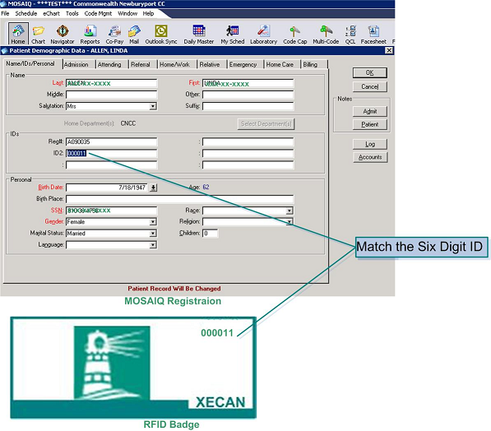

2. Treatment Vault Treatment Processing
When a patient enters treatment vault with a RFID tag, his/her treatment chart is going to be opened automatically in seconds. Therapist needs to finish the screen flow on Mosaiq to see the status changing from “Q” to “C”.

3. Clinic Announcement Message Entry
With IE or Firefox browser and the following URL to enter or modify clinic announcement entry page.
http://10.136.153.52/readerAgent/infoBoard.jsp
One should be able to see the following user interface.
