Suite 400, Building 2
275 Grove St.
Newton, MA 02466
Phone: 617-686-9953 E-Mail: support@xecan.com
1. Tech Support
First VPN in. for reception area queuing problems, view the queuing server through the VNC as shown in the following

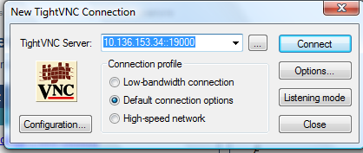

Password is “xecan”.
Once in, makes sure mosaiq is login in. the green and VNC sign are good as shown in the following figure.

The login user and password for mosaiq is “Byang” and “pass”

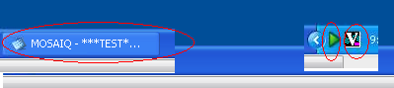

Do the similar for the treatment vault with the following viewer.

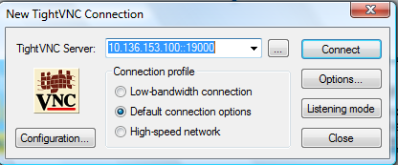

Do the similar for the SIM with the following viewer.

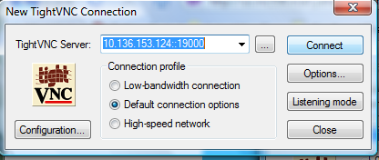

If needed, bounce Jboss app by restarting that service from service
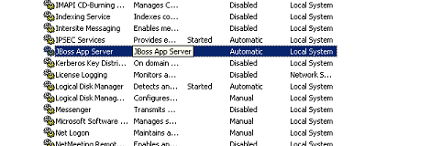''

Also restart the last three XECAN services as marked.
